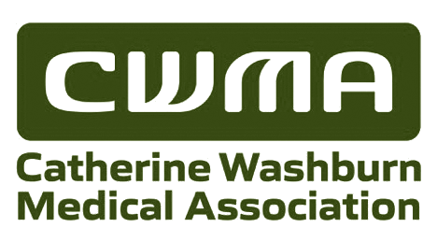

Catherine Washburn Medical Association
S U P P O R T I N G
UW Medicine Lopez Island Clinic and Lopez Island Physical Therapy, LLC
Physician to the Clinic and Advisor to the Board

Robert A Wilson, M.D.

CLINIC MANAGER

Crystal Rovente

BOARD OF DIRECTORS

Diana Hancock, President
Marty Clark, Vice President
George LeBoutillier, Treasurer
Barb Nepom, Secretary
Katherine Bryant
George LeBoutillier
Ann Palmer
Lauren Stephens
Kirman Taylor

ADMINISTRATIVE SUPPORT

Helen Cosgrove
Ann Palmer

PO Box 309
Lopez Island, WA 98261
catherinewashburnmedical.org

Dear Lopez Community Member,

2019 has been an eventful year for the Catherine Washburn Medical Association. We have continued our mission to serve the Lopez community’s health care needs by supporting the UW Lopez Island Clinic. That support includes keeping the Clinic building in good condition and making sure the Clinic medical equipment meets the high standards of our partner. We insured that physical therapy continues to be available on Lopez and revived the Sikstrom Fund to help Lopezians who experience a financial shortfall that limits their access to healthcare.

We worked hand in hand with Lopez Island Physical Therapy to facilitate the move to a new location in the village. This required a remodel of the building to meet code requirements for access, heating and insulation. The new site can accommodate multiple patients which will allow more access for Lopez citizens in need of physical therapy.

We worked with UW to identify needs to provide a safe, well maintained clinic. We purchased better, more efficient lighting. We replaced the refrigerator that stores sensitive medications that must be stored at a carefully controlled temperature. We paid to have delicate medical devices in the Clinic regularly checked and maintained by health care equipment professionals.

All of the work we do is paid for by donations from our members and supporters in the greater Lopez Community. We rely on and appreciate your generosity to continue to support a high standard of medical care on Lopez Island. Since the Catherine Washburn Medical Association was established in 1971 to build the Clinic building, we have relied on the giving spirit of our community to support medical care on Lopez Island. As we expand our mission to include physical therapy on Lopez, our need for your support continues.

Please use the enclosed envelope to join CWMA or to send a contribution.
I sincerely thank you for your support.

Diana Hancock
President, Catherine Washburn Medical Association

